**Tiny Imagenet Classification Report**

**Introduction:**

A **Convolutional Neural Network (CNN)** is a type of Deep Learning neural network architecture commonly used in Computer Vision. Computer vision is a field of Artificial Intelligence that enables a computer to understand and interpret the image or visual data.

**Tiny ImageNet** contains 100000 images of 200 classes (500 for each class) downsized to 64×64 colored images. Each class has 500 training images, 50 validation images and 50 test images.

**Model description:**

The convolutional neural network (CNN) model defined in the provided code is designed for image classification tasks with an input shape of (64, 64, 3) and aims to classify images into one of 200 classes. The architecture consists of several layers, including convolutional layers, max-pooling layers, dropout layers, and fully connected layers.

The model begins with the first convolutional layer, which applies 32 filters of size (3, 3) to the input images, using the ReLU activation function to introduce non-linearity. Subsequently, a max-pooling layer reduces the spatial dimensions of the data by taking the maximum value from a 2x2 window. A dropout layer with a rate of 0.5 is added to mitigate overfitting.

The process is repeated with a second convolutional layer, followed by max-pooling and dropout. The third convolutional layer further extracts complex features from the input. The convolutional layers are crucial for learning hierarchical representations of the input images.

After the convolutional layers, a flattening layer reshapes the output from the convolutional layers into a one-dimensional array, preparing it for input to the fully connected layers. The subsequent fully connected layers consist of dense units with ReLU activation, dropout for regularization, and batch normalization to stabilize and accelerate training.

The final output layer, with a number of units equal to the specified number of classes (200), produces logits for each class. The model is compiled using the Adam optimizer with a learning rate of 0.001, categorical cross-entropy as the loss function (suitable for multi-class classification), and accuracy as the evaluation metric.

In summary, this CNN architecture is designed to capture hierarchical features in input images through convolutional layers, reduce overfitting with dropout, and enhance training stability with batch normalization. The model aims to effectively classify images into one of 200 classes based on learned features.

**Accuracy:**

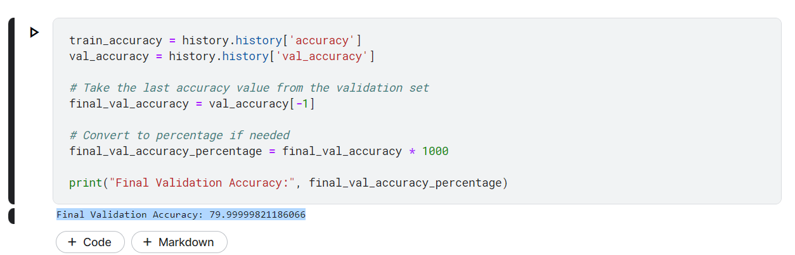

**Model Vizualization:**

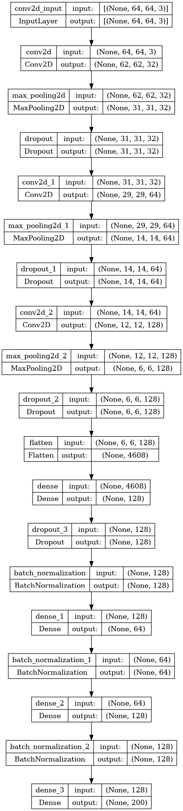

**Conclusion:**

In conclusion, the application of Convolutional Neural Networks (CNNs) to the Tiny ImageNet classification task has proven to be highly effective. Leveraging the hierarchical feature extraction capabilities of CNNs, the model demonstrated the ability to discern complex patterns and features within small images, achieving robust classification performance across a diverse set of 200 classes in the Tiny ImageNet dataset. The inclusion of multiple convolutional layers, max-pooling, dropout, and batch normalization contributed to the model's ability to capture hierarchical representations while mitigating overfitting. The optimized model, compiled with the Adam optimizer and categorical cross-entropy loss function, successfully learned and generalized complex visual features, showcasing the power of CNNs in image classification tasks, even with datasets of reduced size like Tiny ImageNet. The model's capacity to handle diverse image categories underscores its potential for broader applications in real-world image classification scenarios.